## Rasa NLU & Core Installation

### Installation:

#### Requirements:

1. **Python 3.6.x (except 3.6.6)**
2. **Visual Studio:**

**For Windows:**

* Go the Microsoft Visual Studio link: <https://visualstudio.microsoft.com/>

Select the ‘Visual Studio IDE*’* and from the dropdown, select the ‘Community version 2017*’*:



* Install the downloaded file. Once the Visual Studio is installed, select the **Python Development** under ‘Web & Cloud’ Environment. Also, on right side (Summary), in optional menu select the ‘Python native development tools’.

Click on install.

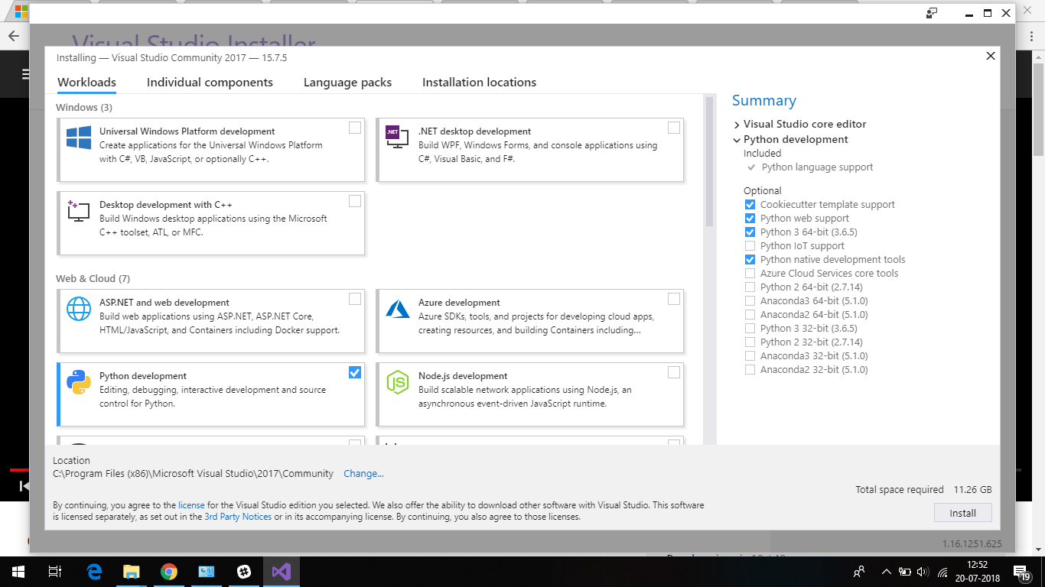

**For Mac:**

* Download visual studio code: <https://code.visualstudio.com/docs/?dv=osx>
* Install the python extension for Visual Studio Code from here. After clicking ‘Install’, click ‘Open Visual Studio Code’ - it will open a VS Code window that you’ve installed in step-1 : <https://marketplace.visualstudio.com/items?itemName=ms-python.python>

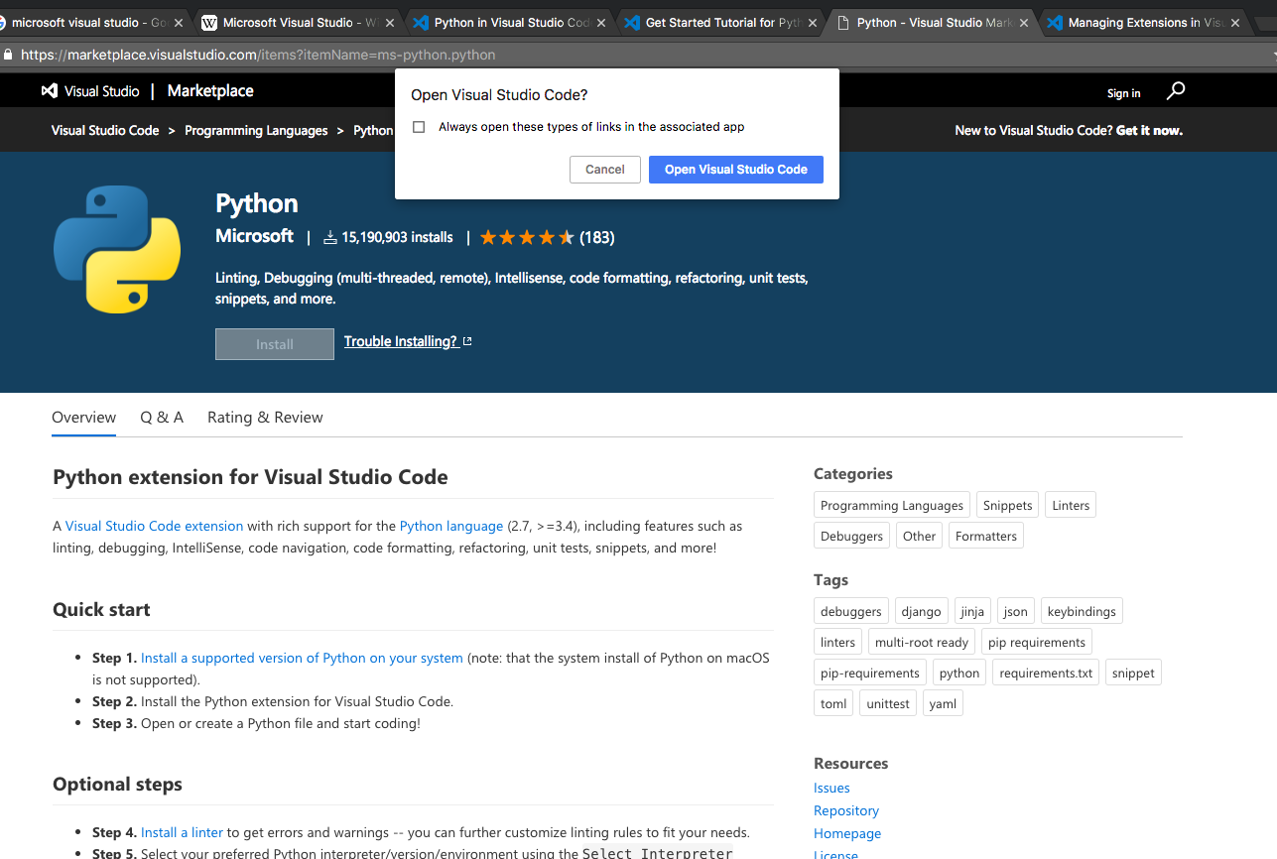

* Install the python extension. If it shows the button ‘Reload’ after installation, click ‘Reload’ to reload VS and enable the python extension.

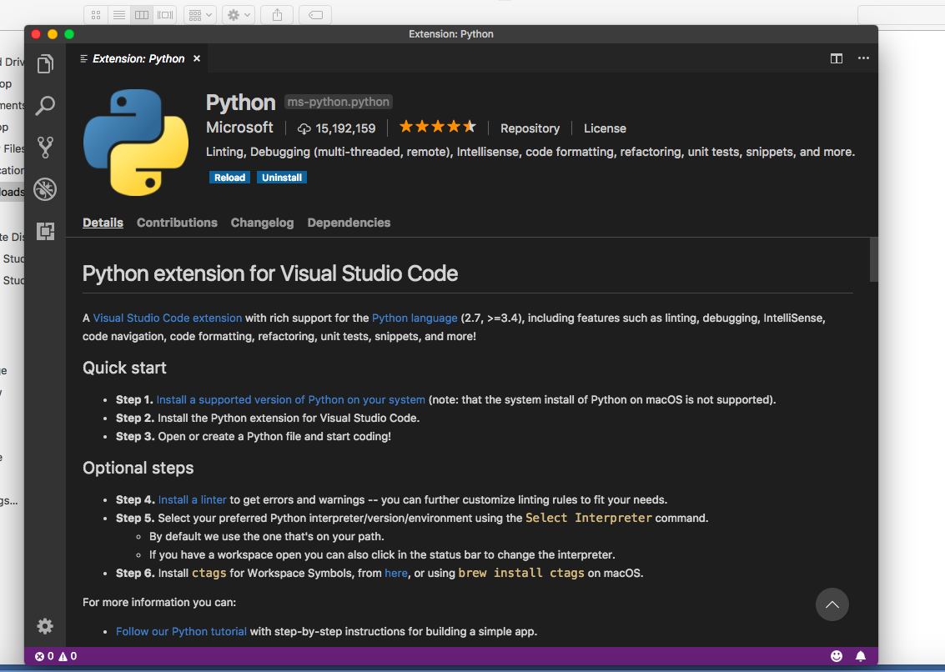

#### Rasa NLU (Requirements and Rasa NLU with Spacy download)

1. Download the zip file from here: <https://github.com/RasaHQ/rasa_nlu>

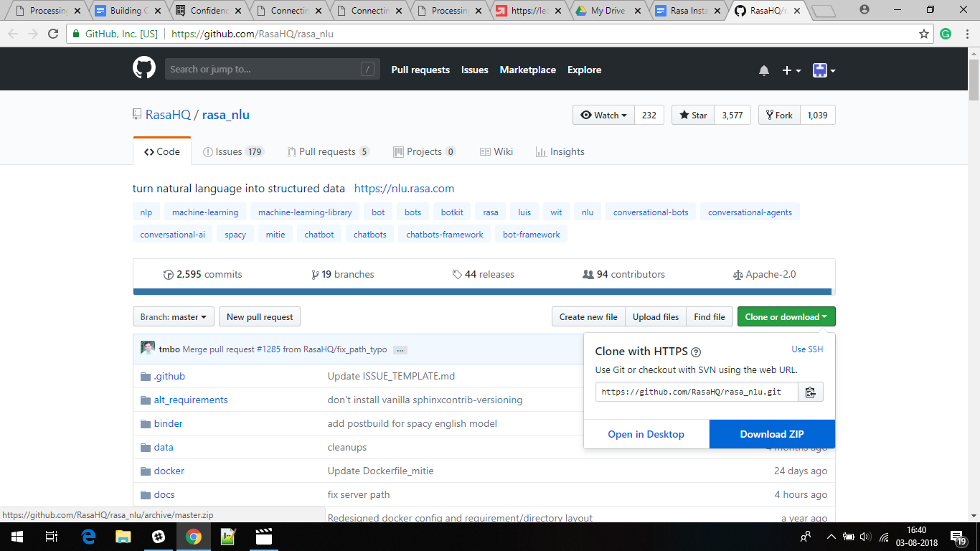

1. Unzip the folder. You’ll get a folder named ‘rasa_nlu-master*’*.
2. Open Anaconda Prompt/ Windows Command Prompt/ Linux Terminal as Administrator to install Rasa.
3. Navigate to ‘rasa_nlu-master’ (the folder which you downloaded from Github) in the command prompt.

cd [path_where rasa_nlu-master folder is located] \rasa_nlu-master

(**Note:** ‘rasa_nlu-master’ folder has rasa_nlu folder. Don’t navigate to that.)

1. Use the file ‘rasa_nlu_requirements.txt’ shared in ‘Installation_Guide.zip’ file and paste it in rasa_nlu folder. And then run the following commands in the Command Prompt:

pip install -r rasa_nlu_requirements.txt

pip install -e

**(Note for Windows**: in case of the error- ‘Microsoft Visual Studio C++ not found’, run the above commands through ‘x64 Native Tools Command Prompt for VS 2017’.)

**(Notes for Mac:**

* you can try using virtualenv:<https://spacy.io/usage/>.
* In case of the following error- ‘Failed building wheel for python-crfsuite’, try using: pip install https://pypi.python.org/packages/source/p/python-crfsuite/python-crfsuite-0.8.1.tar.gz)

1. If system asks to upgrade pip, use the following commands:

**For windows:** python -m pip install --upgrade pip

**For Mac:** pip install pip –upgrade

pip install setuptools –upgrade

1. Install Rasa NLU & Spacy in the same command prompt:

pip install rasa_nlu**[**spacy**]**  
python -m spacy download en_core_web_md

*(By default, it will link spacy with core_web. If it doesn’t, run the following command)*python -m spacy link en_core_web_md en

**Note for Mac Users:** In case of the following error- “*ValueError: unknown locale: UTF-8*”, try resolving it by running the following commands before installing rasa_nlu[spacy]

export LC_ALL=en_US.UTF-8

export LANG=en_US.UTF-8

$ source ~/.bash_profile

And then run:

pip install rasa_nlu**[**spacy**]**  
python -m spacy download en_core_web_md

#### Rasa Core Installation

1. Download the folder from here: <https://github.com/RasaHQ/rasa_core>
2. Unzip the folder and paste the contents to some path. You’ll get a folder named ‘rasa_core-master’
3. Navigate to the ‘rasa_core-master’ folder path in command prompt

cd rasa_core-master

1. Use the file ‘rasa_core_requirements.txt’ shared in ‘Installation_Guide.zip’ file and paste it in rasa_core-master folder.
2. Run the following command to install the Rasa Core requirements:

pip install -r rasa_core_requirements.txt

pip install -e .

### Installing Rasa-NLU-Trainer

1. Rasa has an inbuilt GUI tool for adding/editing the training examples: rasa-nlu-trainer. We’ll download it using npm package manager of node.js environment:
2. Download node.js from <https://nodejs.org/en/> (Version: Recommended for most users)
3. After the installation, run the following command in PowerShell/ Windows Command Prompt

npm i -g rasa-nlu-trainer

For Mac OS: sudo npm i -g rasa-nlu-trainer